- SEE MY DATA -

Provided by Quince Associates, 33 Glebe Avenue, Hunstanton Norfolk PE36 6BS
Tel: 01485 534 109

Contacts:

Spencer Dennis
Professional Services Manager
Quince Associates Limited
07710 980 528
spencer.dennis@quince.co.uk

Tommy Kelly
Customer Support Manager
Quince Associates Ltd
07917 656167
01234 297556
tommy.kelly@quince.co.uk

Tommy Kelly is main contact.

Project files are at Z:\BUSINESS SOLUTIONS TEAM\SeeMyData

Back-end:

The data is exported from UH every night and files are in a folder called ‘SMD Upload’ which is in SeeMyData at the UHM share on ohguhdbo1.

Files are FTP’d to Quince nightly. See below for details. Ryan set up the FTP.

The export was originally set up by Girish but later work was taken over by Paul Vian.

Exported Files :

Renthist - rent transactions
Repairs
Property
Tenants
Rentprop – links tenancies to properties
Contr – list of contractors
Transtype – debit/credit codes. This is static as it contains translations to user friendly descriptions. It will need amending if there are changes, new codes etc.
Repstatu – Repair statuses. Also static as above.
EOF and BOF not sure where these appeared from. Probably not needed.

SFTP Logon Details:

IP Address: 213.198.59.222
Username: onehousing
Password: cpMM76tY

System Admin
Admin controls are web-based, at https://seemydata.org/cgi-home/vcpscripts/admin.pl?client=onehousing

Username | Canberra
Password | Bravo2322

How tenants sign-up:

To register, tenant will be asked to type in:

- Tenancy agreement reference
- First name
- Last name
- Date of birth [important: we must have this on record In Universal Housing]
- Email address
- Password

They will then be emailed a PIN number.

Tenants with garage accounts will need to register those accounts separately.

How tenants log-in:

Each time the tenant logs in they will need:

- Tenancy reference number
- PIN number
- Password [from which they will be asked to enter two randomly selected letters

Setting up an account:

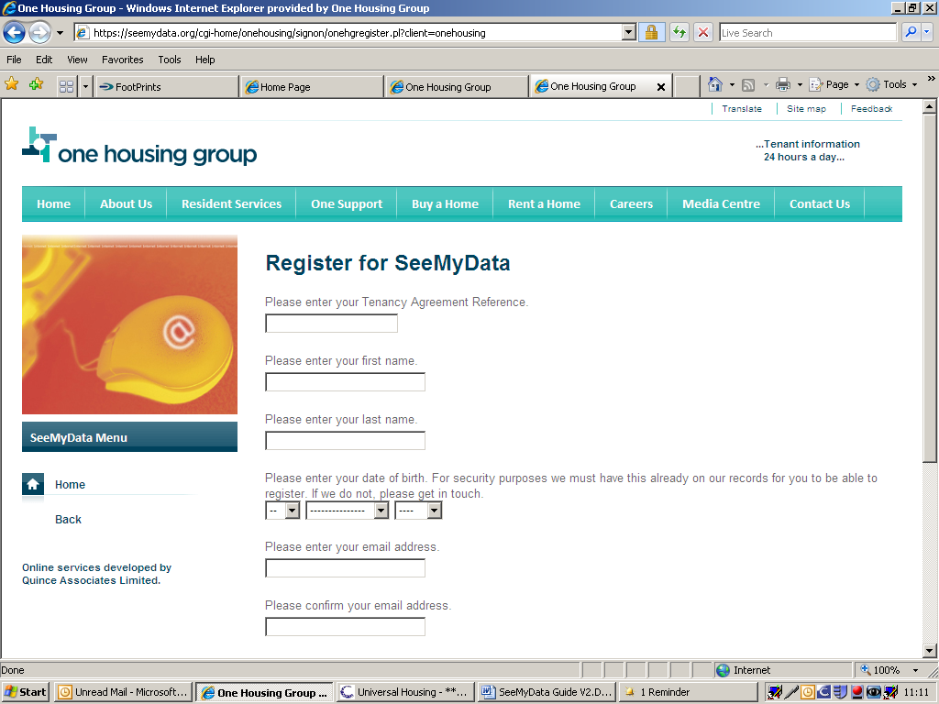

Full ref needed: eg C72712/01
If tenant has 2 accounts they will need to register each one separately

Names must be entered as we have them in database: eg If we have ‘Michael’, tenant cannot register as ‘Mike’.

We may have DOB record on paper if not in Workflow. Complete form for Housing to check if a problem. We will advise tenant if they need to prove DOB

Email addresses
They do not have to be in UH/Workflow

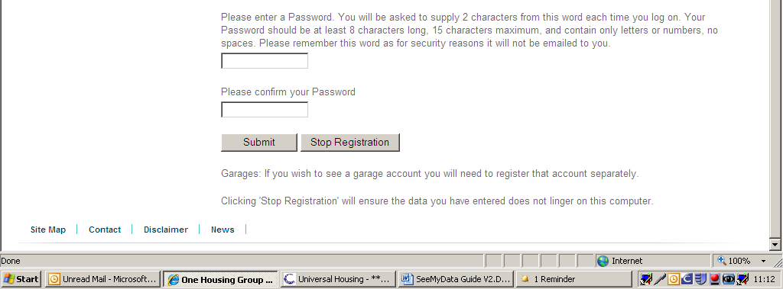

Passwords
8 – 15 characters
Letters and numbers but no symbols

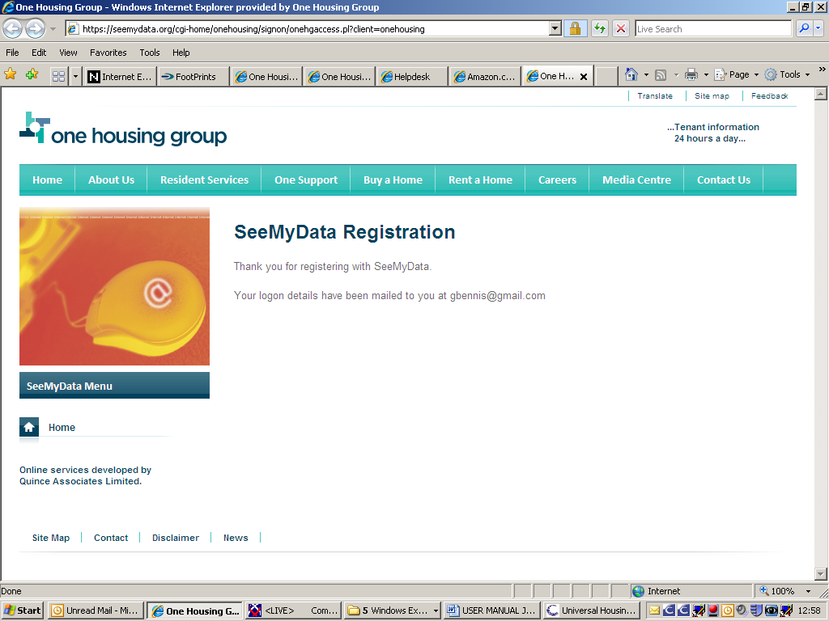

Email to tenant:


New online registration

Welcome to SeeMyData for One Housing Group. You are now able to access these online facilities using this PIN.

PIN: 784840

Logon on at onehousing.seemydata.org

Log-in screen:
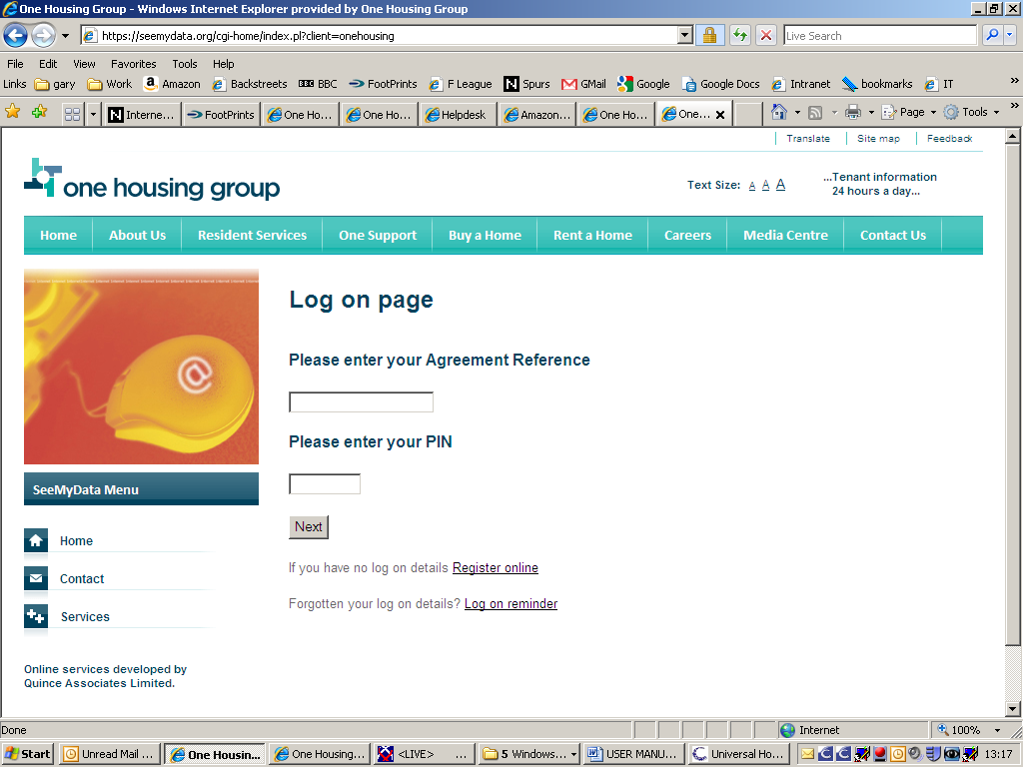

PIN will have been emailed to tenant

A reminder of tenants PIN will be sent to email address

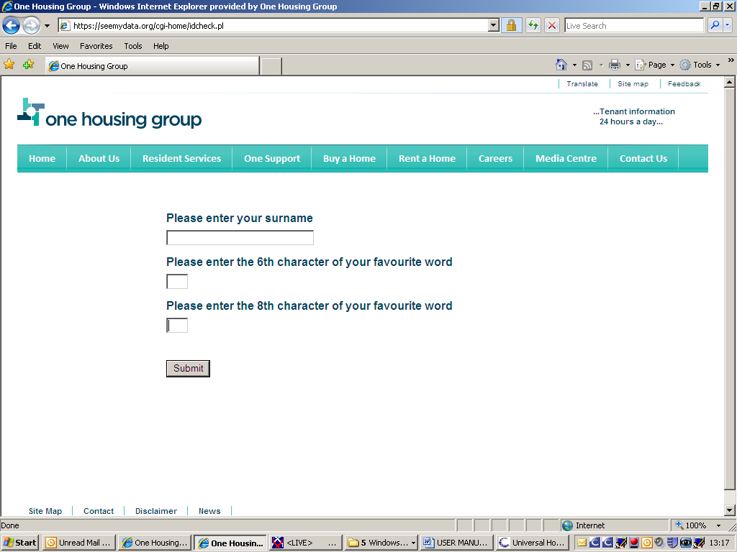

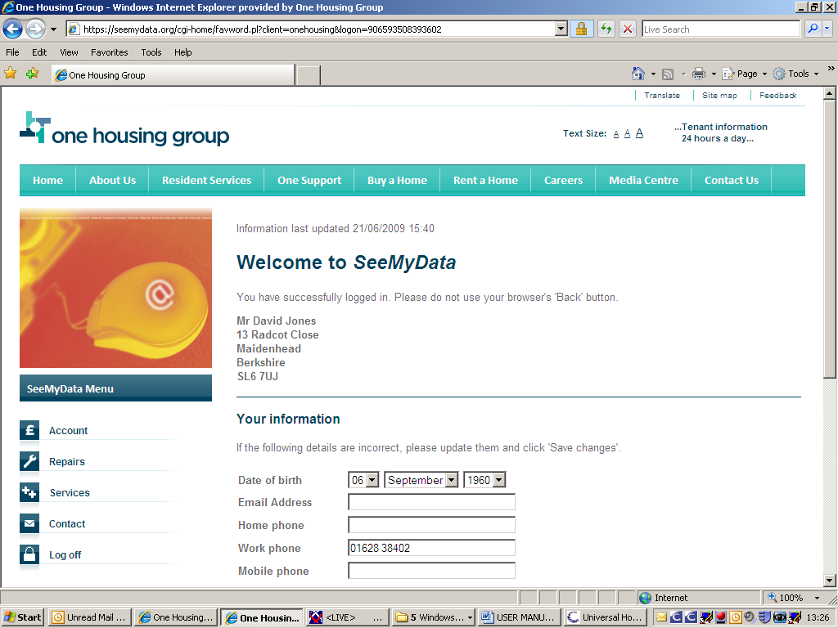

Any changes made here by tenant will be emailed to the Business Solutions Team

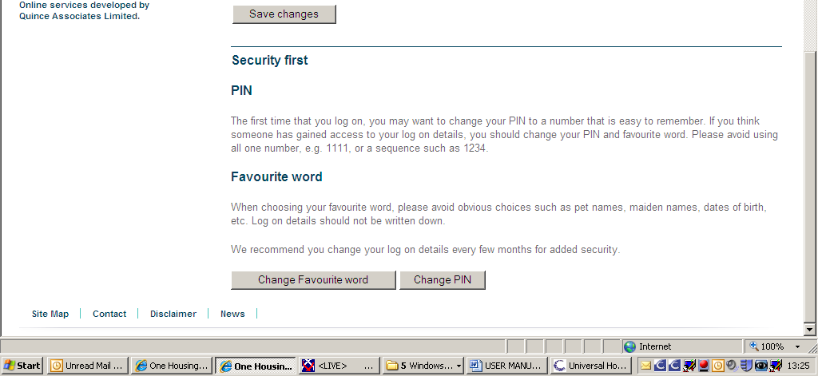

Password and PIN can be changed here

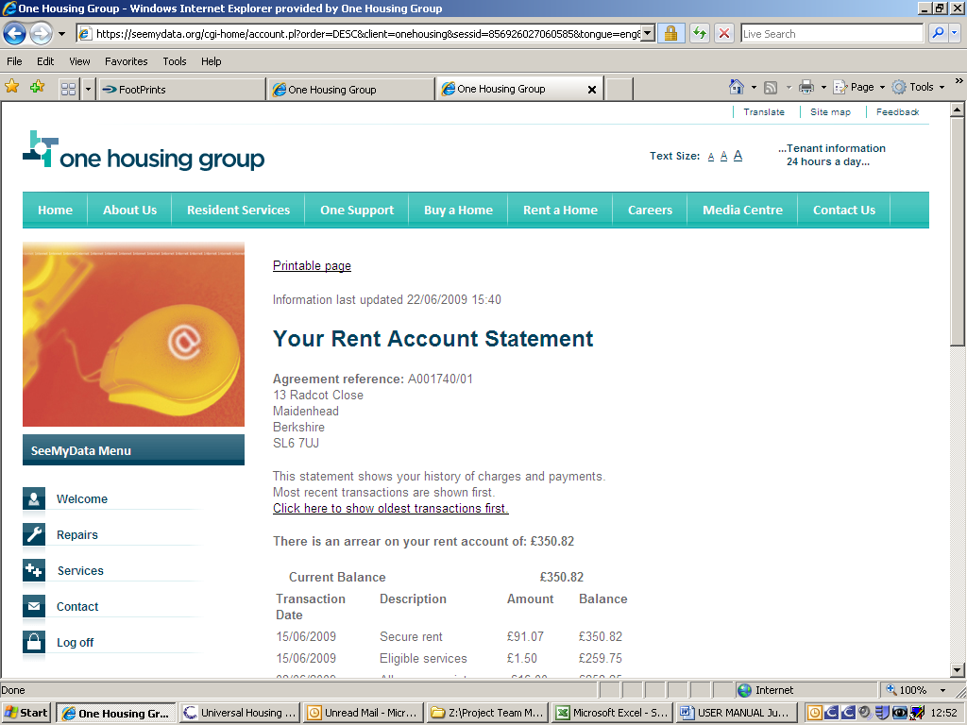

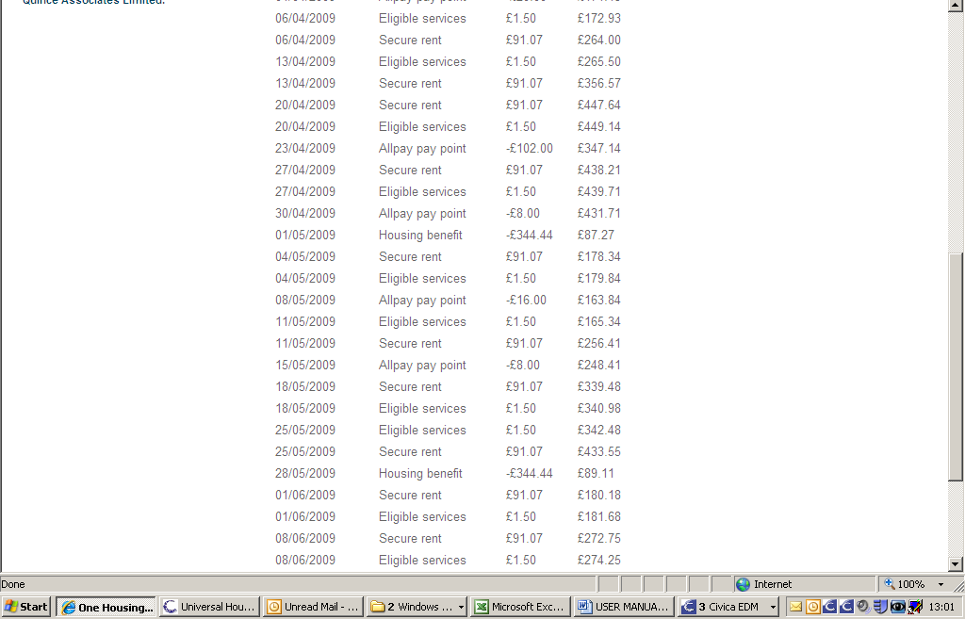

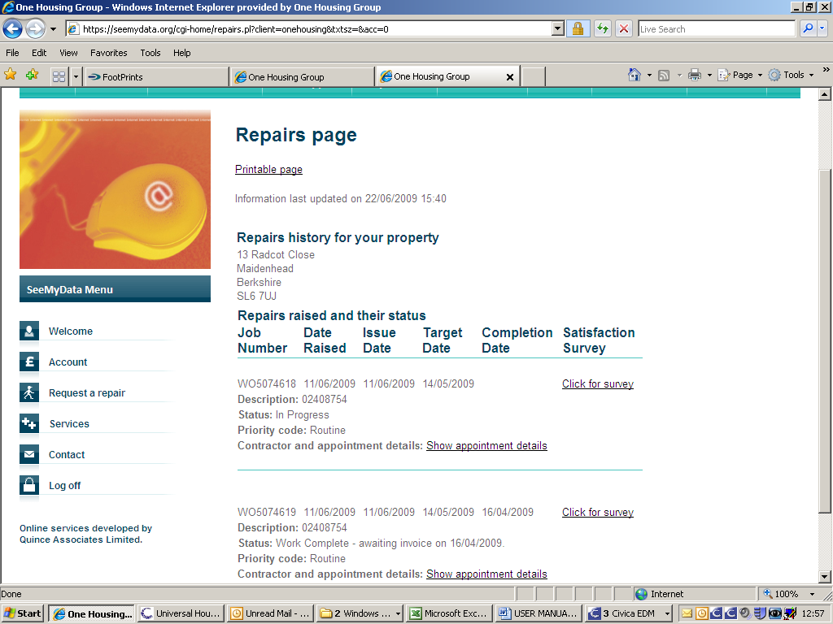

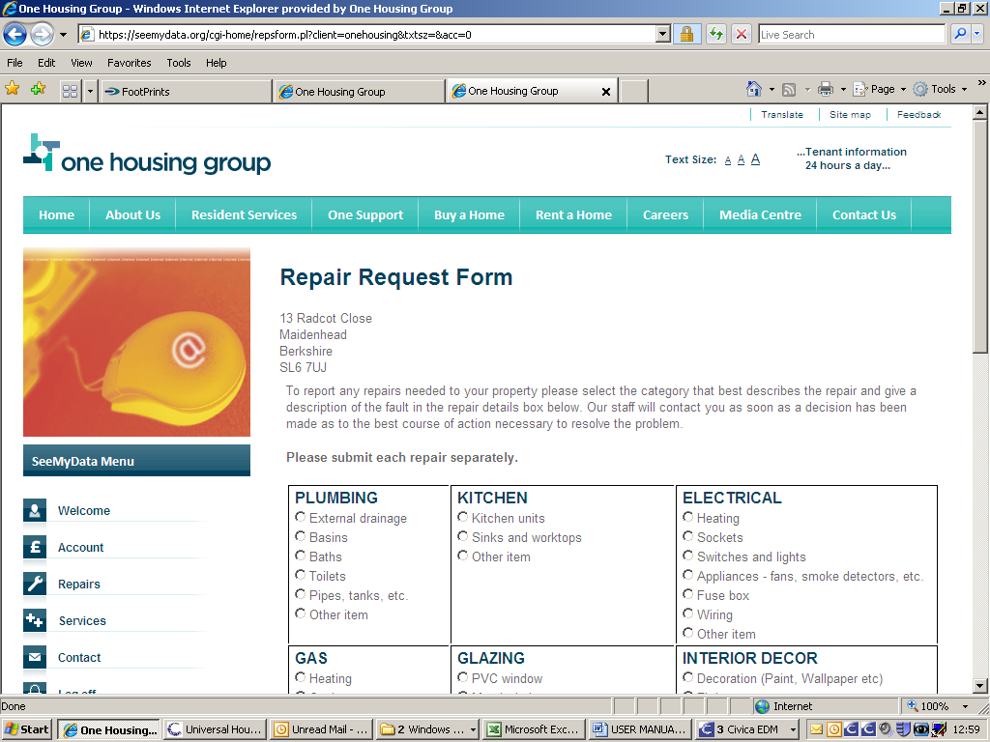

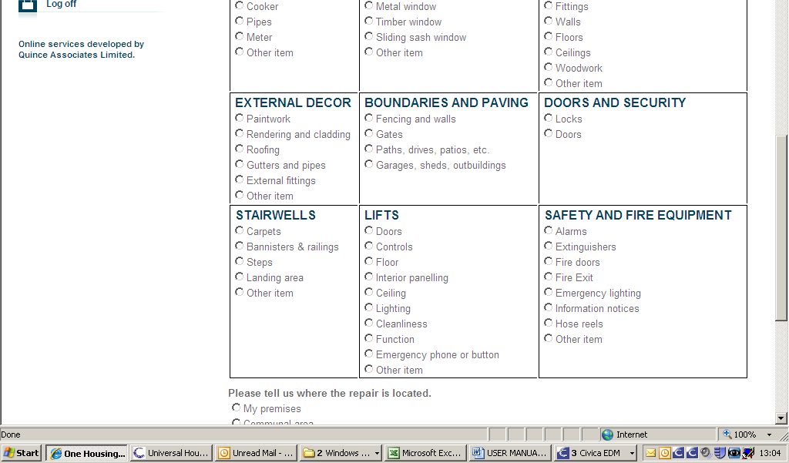

To: Housing Team | Island Homes  Toynbee London  Berkshire  Community | □  □  □  □ |  | Date: / / 20
From: | CCC  BST | □  □
See My Data query

Tenant name:

Address:

Reference:

This tenant has been unable to register for See My Data due to a problem with:

Date of birth: Tenant stated that their D.O.B is ………………………………………

If you are able to confirm this from our records please amend or add to the UH database asap. The tenant has been advised to try to log in again in a few days.

If we have no record of date of birth, please advise the tenant that they will need to provide evidence of their date of birth.

Other [give detail]:

UH record added/amended:  Name:  Date: | Tenant contacted:  Name:  Date: |  | Other action:  Name:  Date:
